National University of Computer and Emerging Sciences, Lahore Campus

 | Course: | Web Engineering Lab | Course Code:
 | Program: | BS(Computer Science) | Semester: | Spring 2024
 | Duration: | 30 minutes | Total Marks: | 25
 | Date | 11-03-2024 | Weight | 5
 | Section: |  | Pages: | 02
 | Name: |  | Roll No.:

Exam instructions: READ ALL INSTRUCTIONS CAREFULLY.

- Understanding the question is also part of the quiz, so do not ask for any clarification. Make suitable ASSUMPTIONS in case of any issues.
- Final Submissions should be done on xeon as well as on Google classroom on your respective section folder on:

\\Xeon/Spring 2024/Marwa Khan/Web Engineering Lab/Quiz/Submissions
Question must be saved with your roll no e.g: “”20L-4444”. Multiple submissions are not allowed (if done, only the first one will be considered). In case of missing or corrupt file submission, all the responsibility will be on the student himself.
- Your cell phones/smart watches MUST be turned off and placed far away from the PCs.
- It is your responsibility to protect your code and save it from being copied. If you don’t protect it, all matching codes will be considered copy/cheating cases. No leniency on plagiarism.
- Any kind of cheat sheet/code if found in your PC will result in immediate disqualification from Quiz and it will be marked as 0. So, make sure you delete everything from the Desktop of your windows. Also delete all the files permanently from Recycle Bin and Trash respectively for Windows.
- Submission should also have screen shot of the output.
- Your quiz will be immediately cancelled if:
  - You are seen talking, whispering, borrowing or looking at someone’s PC.
  - A USB is found attached to your PC.
  - You are seen using a cell phone/smart watch.
  - You are caught accessing internet.

Question:
Write a code to achieve the following template, you have to follow the following restrictions:
- Use div
- Use external css
- The page should be responsive using bootstrap
- Tick sign will come using: &#10004;
- Arrow will come using: &#8680;
- Background color used in:
  - Contact Us to get ---- is: background: #000000d6;
  - Contact Us Now is: background: #000000a3;

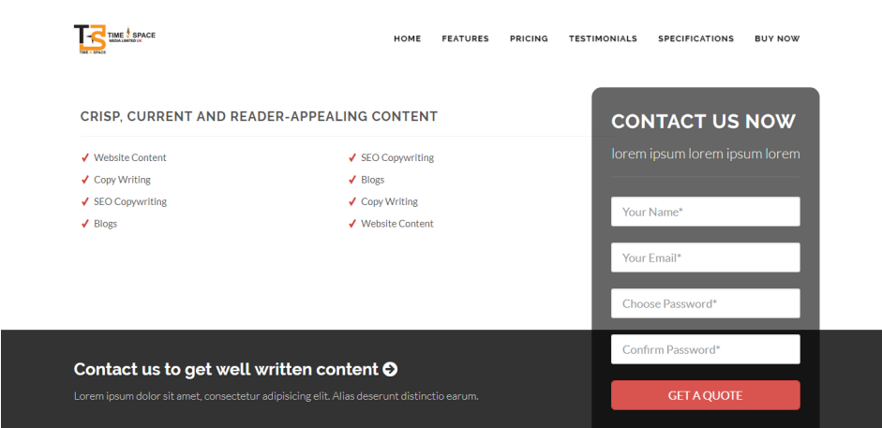

Rubric:
- HTML10 Marks
- CSS5 Marks
- Responsive using bootstrap5 Marks
- Page accuracy according to given template5 Marks

Best of Luck J

